Renju lesson on February 7, 2002

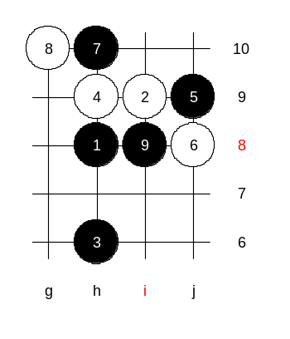
Hello everyone! Welcome to Online Renju Class. Today is the last lesson about i10 opening. Today lets learn about the upper 7th move, ok? This was the main variant of the whole i10 opening long ago. Do you know where white usually plays here? White goes g10, indeed. But why? First of all, it is an active move. But it is especially good because it forces black to play inside the pattern, to i8. That way white escapes from being surrounded by black.
The following moves are quite natural.
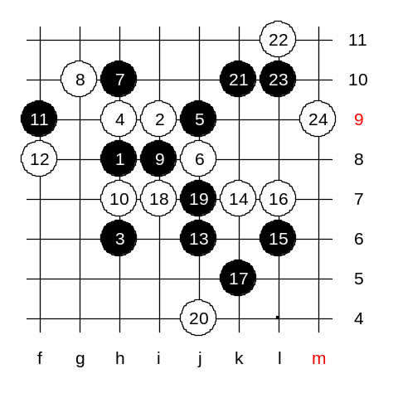
After 12 moves, the positional looks very similar with i11 opening, except with the small shift of h6 stone. There are so many 13th moves possible. Almost any move is ok. This position gives black small advantage. The most popular 13th moves are j6, k7, f7.
Since it is so equal, it is impossible to continue with a forced variant, therefore I just pick one example path and go on with it. Black’s attack is strong despite white’s best moves. After 23rd move black is close to win. Black has good connections through lower side, and promising upper side space move j12. Move 24-m9 is forced. It breaks both the connection and reduces the power of j12 point. After that, black is still strong but no win. Naturally, black will continue attacking through the left side, but it is all matter of game.

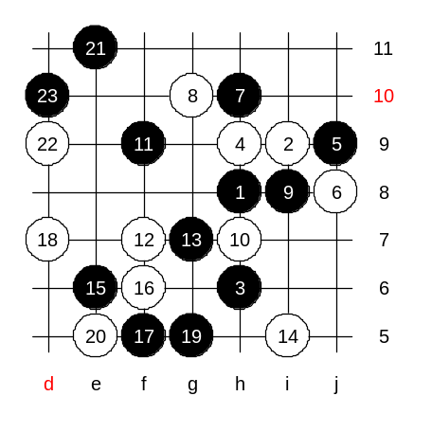
We change the 12th move now. We go f7, as some of you proposed. I made an analysis about it long time ago, and proved black win here. It starts with g7. I tried all blocks here, and the strongest of them are i5 and f8. We try i5 first. I looked all possible 16th moves here. Move 16-f6 is the best block. Move 18-d7 is forced already. Move e5 is forced, otherwise easy win. Move 21-e11 – golden win move. Let me explain it for you. All the previous moves were the preparation of lines and key fields while white was forced to play the only moves. Move 21th – a space move that calls the inside stones h8, i8, h10, g7, g5, h6 into active war. That group of inside stones serve one purpose – to force white block the VCT while black keeps the whole upper space. Now you must agree that if white plays passively, like f10, then black wins with d11. The best block here is d9, it cuts the VCT! It is white’s last hope. But black’s next (23rd) move is killing though. Black wins. All blocks lose so fast.

Shall we check another 14th move now?
We play 14-f8. Do you see the win already? Well, the longest variant is over 80 moves. :)
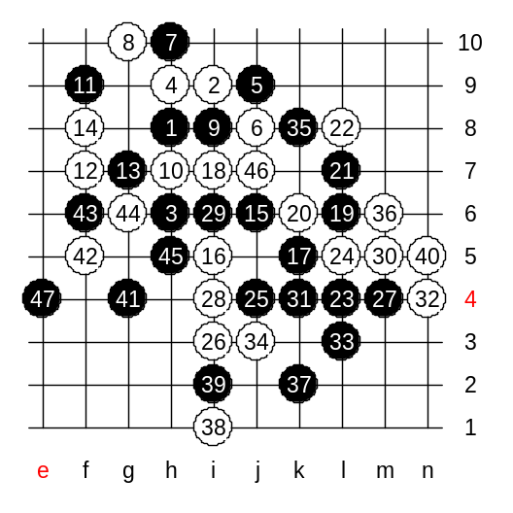
Note that white moves are all forced. After 30 moves, I searched a long time. It was not easy to find the win. It took another 50 moves to get there from here. All forced.
Which 34th move is forced? Yes, j3. The next black move is quite “hidden”. It might not be easy to be understood at first.
Black wins.
But if we go j1 instead of n5 then the lower side win doesn’t work. Agree?

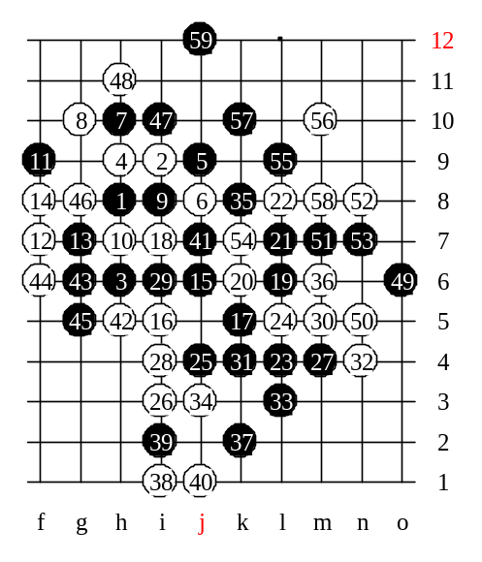
Now after j1, it becomes clear the idea of 35-k8. If black didn’t play it in time, then n5 would become 4x4 that would bother future attacks.
Move j7 – preparation move. White gets 4x3 threat and black is forced to defend. Actively though.
Now, black will use all it has.
Move j12 – opening the new world! We have 59 stones now. In case of the strongest defense, we need 20 more moves. But, we stop here!! Because…. :)
This will be your homework.

